***(Proposed Cover Page)***

***Connie Sue’s Family Lines***

***Casteel (almost done)***

***Howell (in progress)***

***Coucher (in progress)***

***Jenkins (in progress)***

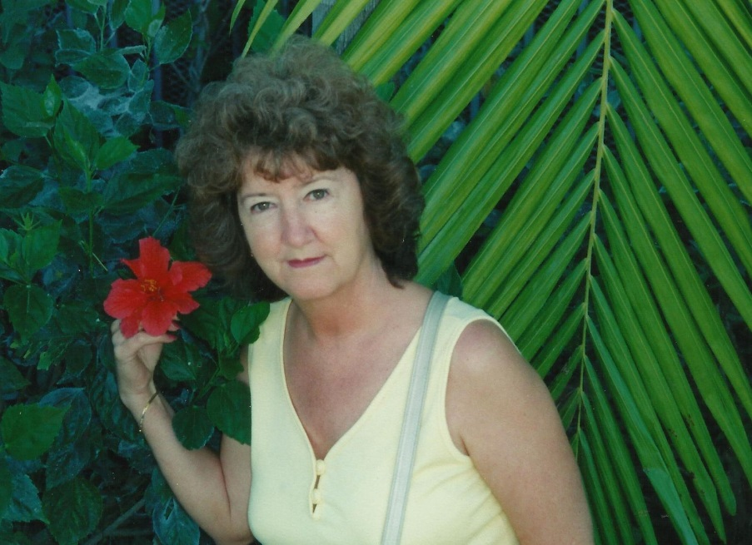

***Connie Sue Howell-Jenkins was born 29 Jan 1946***

***in Morgantown, WV. She was reared by a loving***

***foster mother, Edith May Croucher, and married***

***Kenneth James Jenkins. These are her stories.***

***Published: 26 September 2018 [example, not published]***

***Copyright: 26 September 2018***